1. **Write a PHP program to display the student records which are stored in the database.**

**CODE :**

<?php

function OpenCon()

{

$dbhost = "localhost";

$dbuser = "root";

$dbpass = "";

$db = "cse";

$conn = new mysqli($dbhost, $dbuser, $dbpass, $db) or die("Connection failed : %s \n".$conn -> connect_error);

return $conn;

}

function CloseCon($conn)

{

$conn -> close();

}

?>

**OUTPUT :**



**CODE :**

<?php

include 'db_connection.php';

$conn = OpenCon();

echo "Connected Successfully";

CloseCon($conn);

?>

**CODE :**

<?php

include "db_connection.php";

$conn = OpenCon();

if ($conn -> error)

{

die("Connection failed : " . $conn -> error);

}

$sql = "CREATE TABLE MyGuests (id INT(6) UNSIGNED AUTO_INCREMENT PRIMARY KEY, firstname VARCHAR(30) NOT NULL, lastname VARCHAR(30) NOT NULL, email VARCHAR(50), reg_date TIMESTAMP DEFAULT CURRENT_TIMESTAMP ON UPDATE CURRENT_TIMESTAMP)";

if ($conn->query($sql) === TRUE)

{

echo "Table MyGuests created successfully";

}

else

{

echo "Error creating table : " . $conn -> error;

}

$conn -> close();

?>

**OUTPUT :**

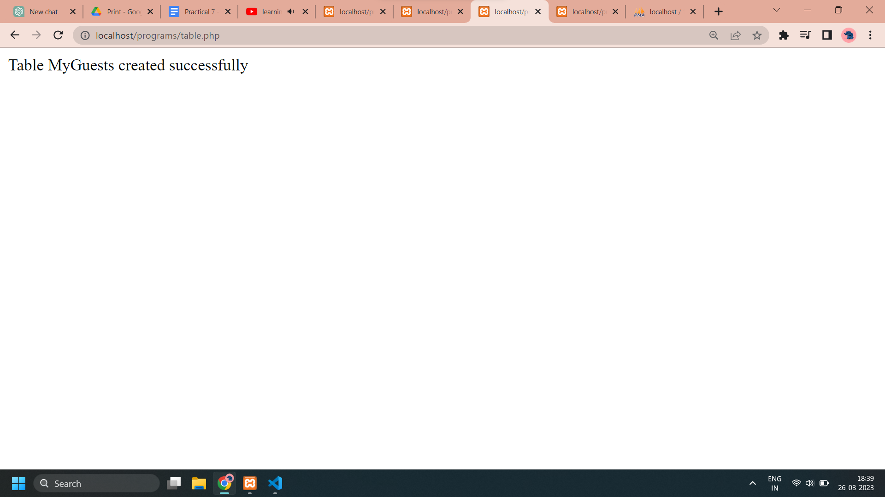

**CODE :**

<?php

include "db_connection.php";

$conn = OpenCon();

if ($conn->connect_error)

{

die("Connection failed : " . $conn -> connect_error);

}

$sql = "INSERT INTO MyGuests (firstname, lastname, email) VALUES ('John', 'Doe', 'john@example.com')" ;

if ($conn -> query($sql) === TRUE)

{

echo "New record inserted successfully";

}

else

{

echo "Error : " . $sql . "<br>" . $conn -> connect_error;

}

$conn -> close();

?>

**OUTPUT :**

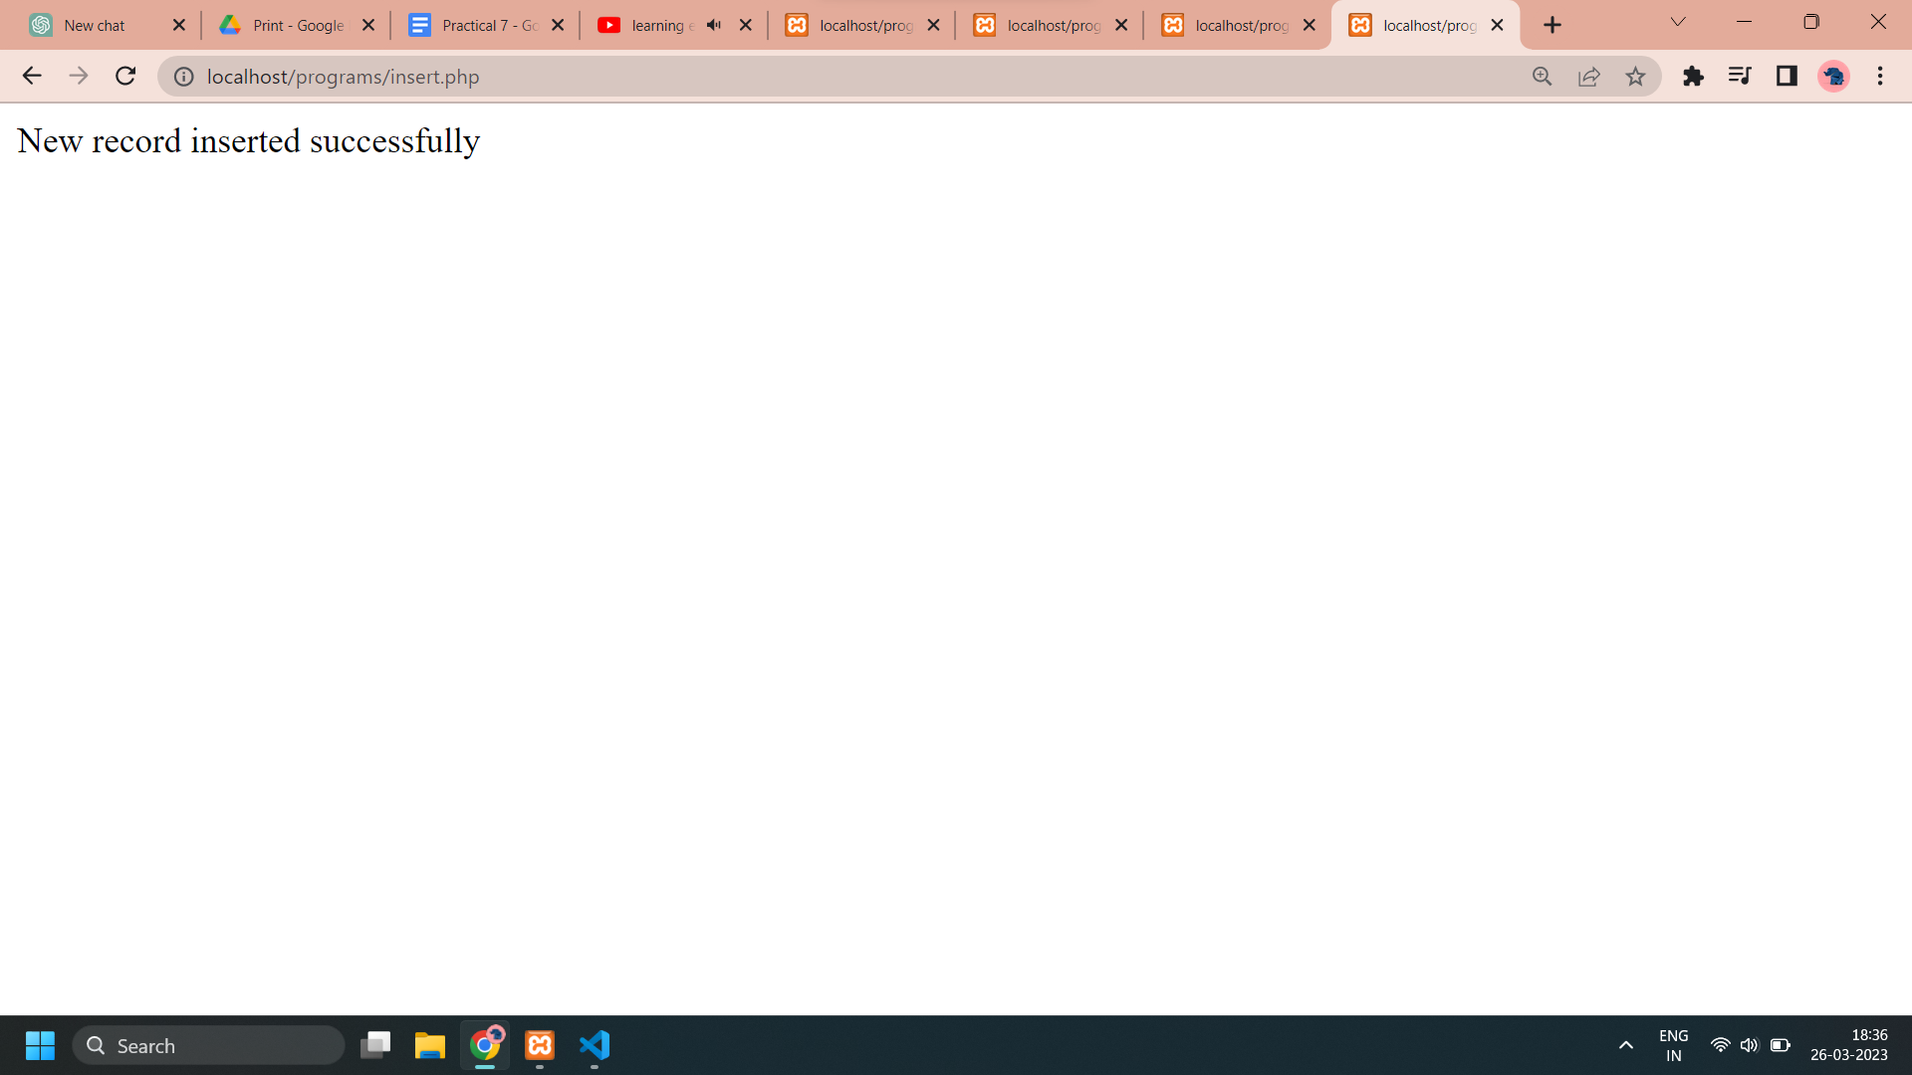

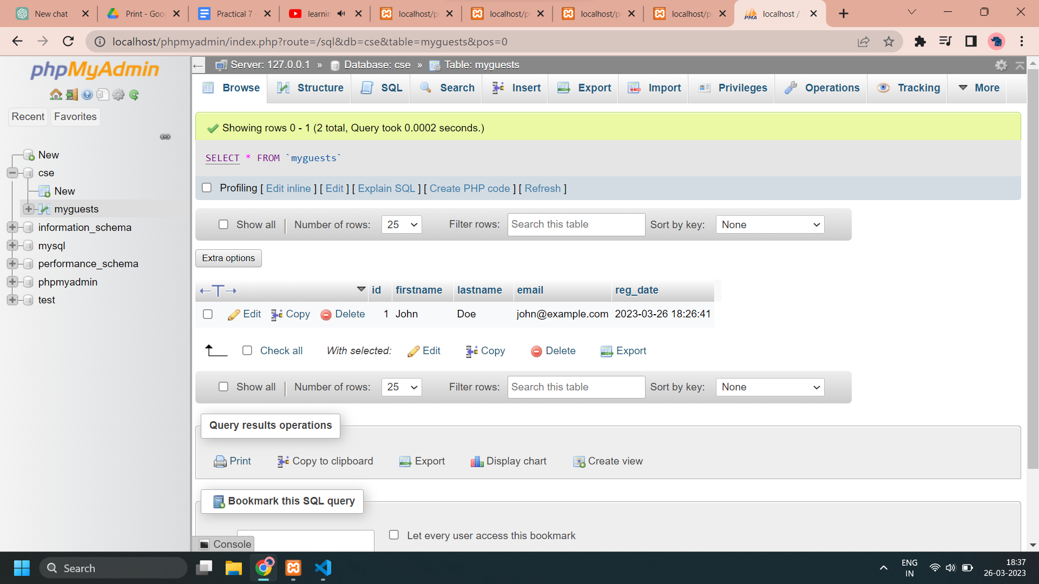

**CODE :**

<?php

include "db_connection.php";

$conn = OpenCon();

if ($conn->error)

{

die("Connection failed : " . $conn -> error);

}

$sql = "UPDATE MyGuests SET lastname='Devgan' WHERE id=1" ;

if ($conn -> query($sql) === TRUE)

{

echo "Record updated successfully";

}

else

{

echo "Error updating record : ". $conn -> error;

}

$conn -> close();

?>

**OUTPUT :**



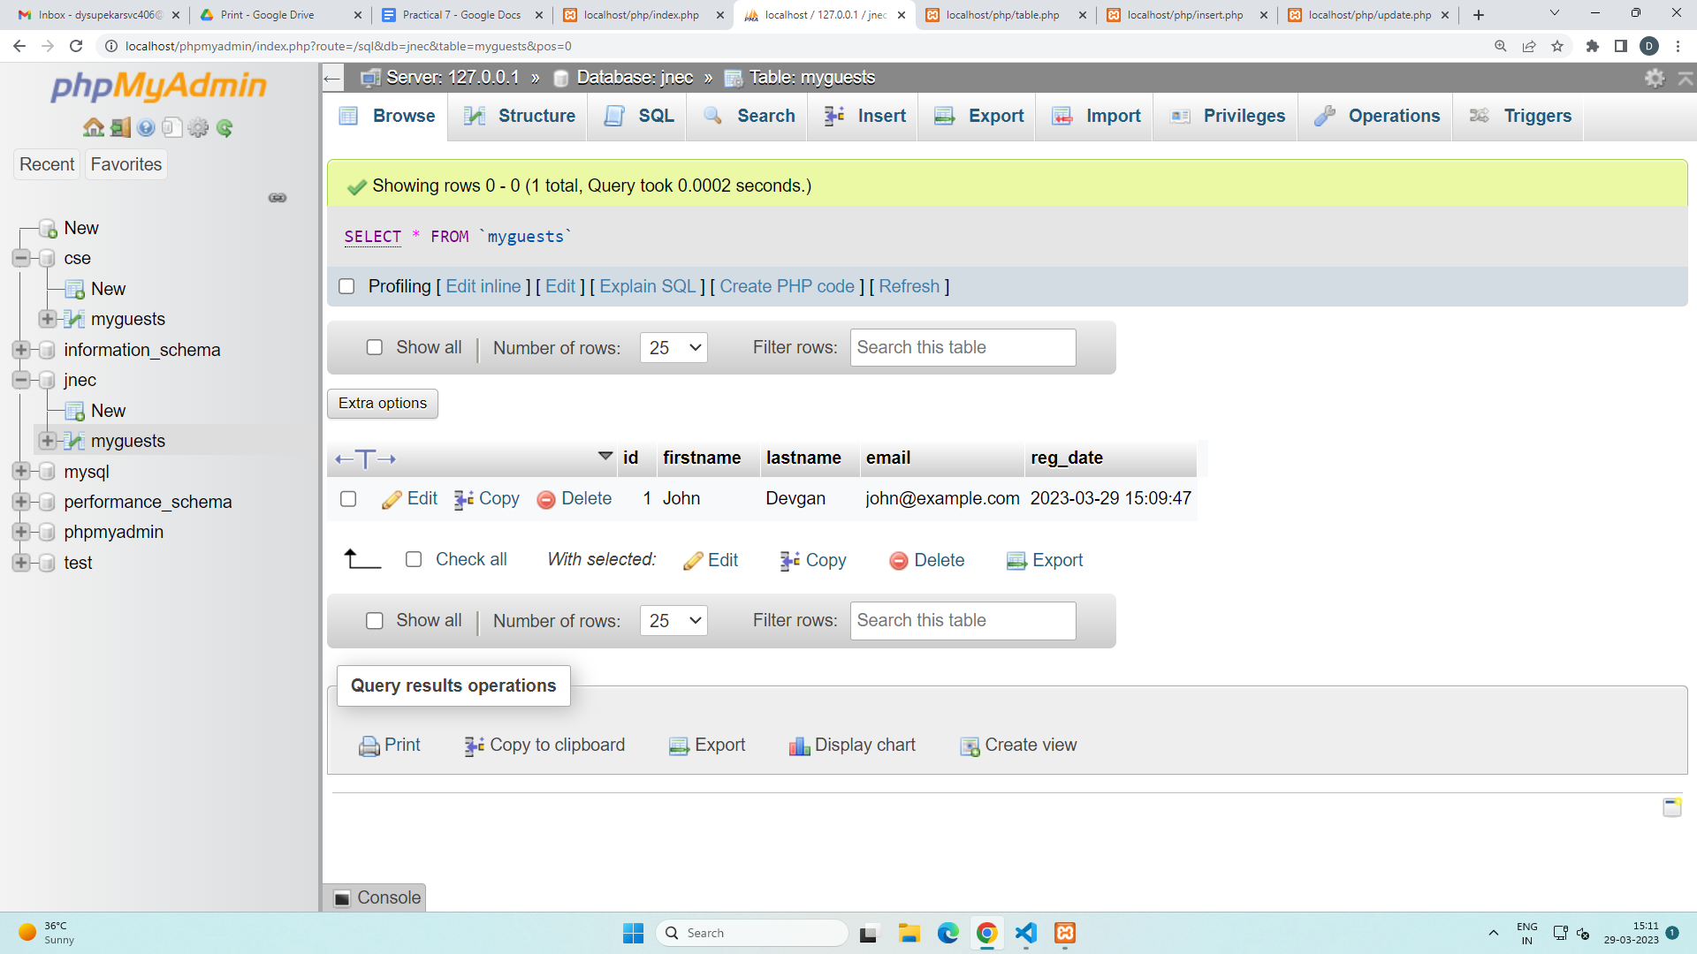

**CODE :**

<?php

include "db_connection.php";

$conn = OpenCon();

if ($conn->error)

{

die("Connection failed : " . $conn -> error);

}

$sql = "DELETE FROM MyGuests WHERE id=1" ;

if ($conn -> query($sql) === TRUE)

{

echo "Record deleted successfully";

}

else {

echo "Error deleting record :" . $conn -> error;

}

$conn -> close();

?>

**OUTPUT :**



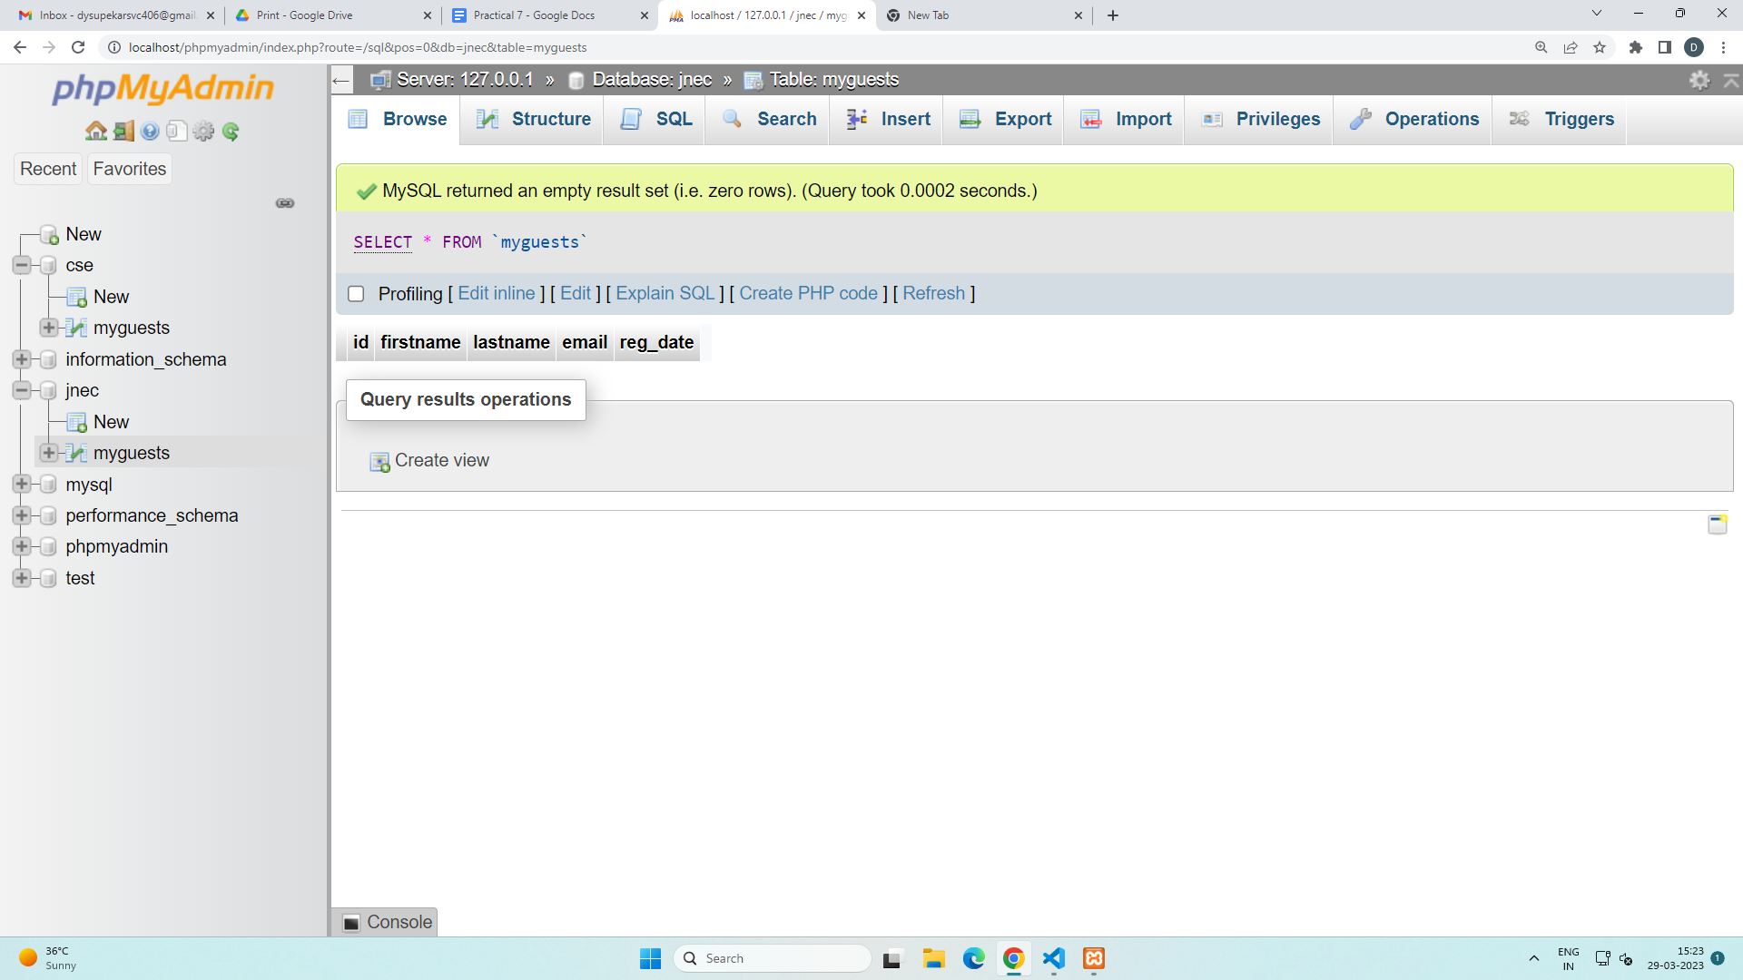

**CODE :**

<!DOCTYPE html>

<html lang="en">

<head>

<meta charset="UTF-8">

<meta http-equiv="X-UA-Compatible" content="IE=edge">

<meta name="viewport" content="width=device-width, initial-scale=1.0">

<title>Database</title>

<style>

table

{

border-collapse: collapse;

width : 50%;

color : blue;

font-family : monospace;

font-size : 25px;

text-align : center;

}

th

{

background-color: lightcoral;

color : white;

}

tr:nth-child(even)

{

background-color: #f2f2f2;

}

p

{

color : brown;

font-size : 30px;

text-align : center;

}

.center

{

margin-left : auto;

margin-right : auto;

}

</style>

</head>

<body>

<p><u>Select From Database Table</u></p>

<table class="center">

<tr>

<th>ID</th>

<th>NAME</th>

</tr>

<?php

include 'db_connection.php';

$conn = OpenCon();

if($conn -> connect_error)

{

die("Connection failed : " . $conn -> connect_error);

}

$sql = "SELECT id, firstname, lastname FROM MyGuests";

$result = $conn -> query($sql);

if($result -> num_rows > 0)

{

while($row = $result -> fetch_assoc())

{

echo "<tr><td>" . $row["id"] . "</td><td>" . $row["firstname"]. " " . $row["lastname"]. "</td>"."<br>";

}

echo "</table>";

}

else

{

echo "0 results";

}

$conn -> close();

?>

</body>

</html>

**OUTPUT :**

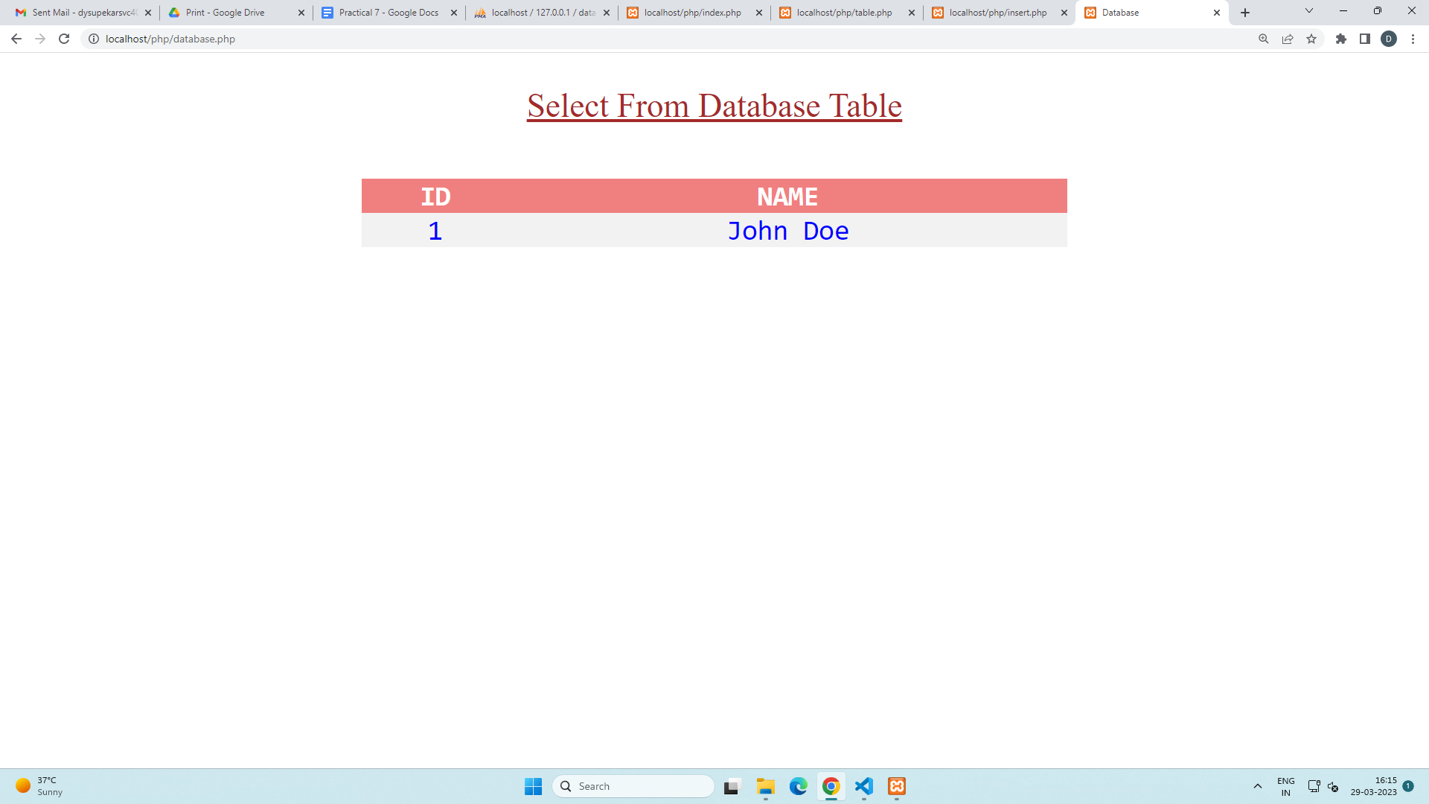

1. **Write the PHP programs to do the following:**
2. **Implement simple calculator operations.**

**b. Find the transpose of a matrix.**

**c. Multiplication of two matrices.**

**d. Addition of two matrices.**

**CODE :**

<?php

$a = array(array(1,2,3),array(4,5,6),array(7,8,9));

$b = array(array(7,8,9),array(4,5,6),array(1,2,3));

$m=count($a);

$n=count($a[2]);

$p=count($b);

$q=count($b[2]);

echo "The First Matrix :"."<br/>";

for ($row = 0; $row < $m; $row++)

{

for ($col = 0; $col < $n; $col++)

echo " ".$a[$row][$col];

echo "<br/>";

}

echo "The Second Matrix :"."<br/>";

for ($row = 0; $row < $p; $row++)

{

for ($col = 0; $col < $q; $col++)

echo " ".$b[$row][$col];

echo "<br/>";

}

echo "The Transpose for the First Matrix is :"."<br/>";

for ($row = 0; $row < $m; $row++)

{

for ($col = 0; $col < $n; $col++)

echo " ".$a[$col][$row];

echo "<br/>";

}

echo "The Addition of Matrices is :"."<br/>";

for ($row = 0; $row < 3; $row++)

{

for ($col = 0; $col < 3; $col++)

echo " ".$a[$row][$col]+$b[$row][$col]." ";

echo "<br/>";

}

echo " The Multiplication of Matrices: <br/>";

$result=array();

for ($i=0; $i < $m; $i++)

{

for($j=0; $j < $q; $j++)

{

$result[$i][$j] = 0;

for($k=0; $k < $n; $k++)

$result[$i][$j] += $a[$i][$k] * $b[$k][$j];

}

}

for ($row = 0; $row < $m; $row++)

{

for ($col = 0; $col < $q; $col++)

{

echo " ".$result[$row][$col];

}

echo "<br/>";

}

?>

**OUTPUT :**

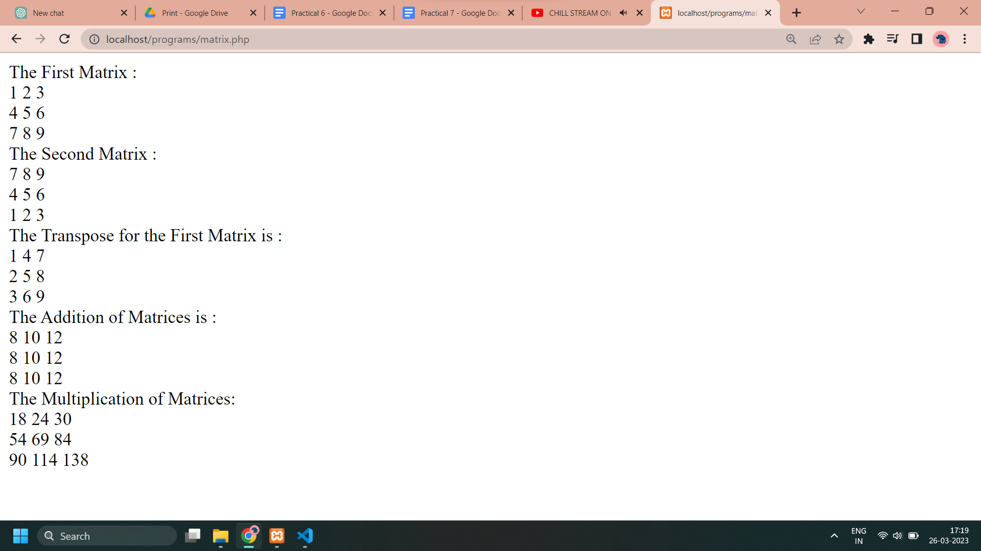

**CODE :**

<html>

<head>

<style>

table, td, th {

border: 1px solid black;

width: 35%;

text-align: center;

background-color: lightblue;

}

table {

margin: auto;

}

input,p {

text-align:right;

}

body {

text-align:center;

}

</style>

</head>

<body>

<form method="post" >

<table>

<caption><h2> SIMPLE CALCULATOR </h2></caption>

<tr>

<td>First Number:</td><td><input type="text" name="num1" /></td>

<td rowspan="2"><button type="submit" name="submit" value="calculate">Calculate</td></tr>

<tr>

<td>Second Number:</td><td><input type="text" name="num2"/></td>

</tr>

</form>

<?php

if(isset($_POST['submit']))

{

$num1 = $_POST['num1'];

$num2 = $_POST['num2'];

if(is_numeric($num1) and is_numeric($num2) )

{

echo "<tr><td> Addition :</td><td><p>".($num1+$num2)."</p></td>";

echo "<tr><td> Subtraction :</td><td><p> ".($num1-$num2)."</p></td>";

echo "<tr><td> Multiplication :</td><td><p>".($num1*$num2)."</p></td>";

echo "<tr><td>Division :</td><td><p> ".($num1/$num2)."</p></td>";

echo "</table>";

}

else

{

echo"<script> alert(' ENTER VALID NUMBER');</script>";

}

}

?>

</body>

</html>

**OUTPUT :**

